# **Unix/Linux - Print , Email , Install New Software**

Let’s try out some easy commands which **can print files** in a format you want. What more, your original file does not get affected at all by the formatting that you do. Let us learn about these commands and their use.

## **'pr' command**



This command helps in formatting the file for printing on the terminal. There are many options available with this command which help in making desired format changes on the file. The most used '**pr'** options are listed below.

|  |  |
| --- | --- |
| **Option** | **Function** |
| -x | Divides the data into 'x' columns |
| -h "header" | Assigns "header" value as the report header |
| -t | Does not print the header and top/bottom margins |
| -d | Double spaces the output file |
| -n | Denotes all line with numbers |
| -l page length | Defines the lines (page length) in a page. Default is 56 |
| -o margin | Formats the page in accordance with the margin number |

Let us try some of the options and study their effects.

**Dividing data into columns**

'**Tools'** is a file (shown below) .

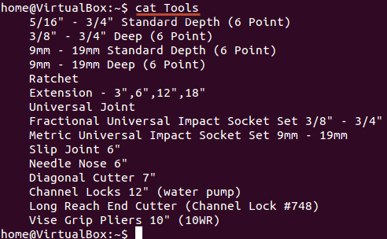

We want its content to be arranged in three columns. The syntax for the same would be:

***pr -x Filename***

The '-x' option with the 'pr' command divides the data into x columns.

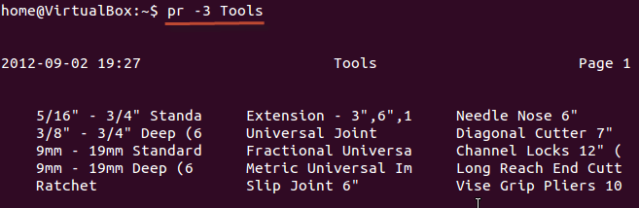

**Assigning a header**

The syntax is:

***pr -h "Header" Filename***

The '-h' options assigns "header" value as the report header

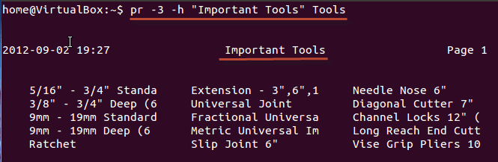

As shown above, we have arranged the file in 3 columns and assigned a header

**Denoting all lines with numbers**

The syntax is:

***pr -n Filename***

This command denotes all the lines in the file with numbers

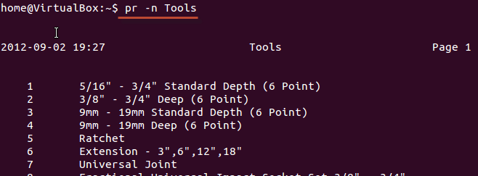

These are some of the 'pr' command options that you can use to modify the file format.

**Printing a file**

Once you are **done with the formatting** and it is time for you to get a **hard copy** of the file, you need to use the following command:

***lp Filename***

or

***lpr Filename***

In case you want to print multiple copies of the file, you can use the number modifier.

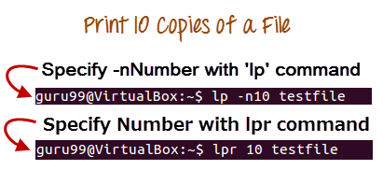

In case you have multiple printers configured, you can specify a particular printer using the Printer modifier

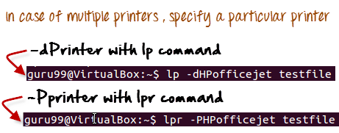

## **Installing Software**

In windows the installation of a program is done by running the setup.exe file. The installation bundle contains the program as well various dependent components required to run the program correctly.

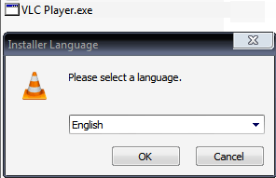

In Linux/UNIX , installation files are distributed as packages. But the package contains only the program itself. Any dependent components will have to be installed separately which are usually available as packages themselves.

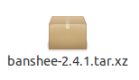

You can use the **apt** commands to install or remove a package. Let's updated all the installed packages in our system using command -

***sudo apt-get update***

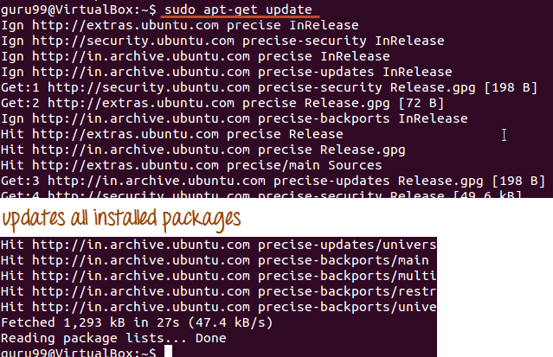

The easy and popular way to install programs on Ubuntu is by using the Software center as most of the software packages are available on it and it is far more secure than the files downloaded from the internet.

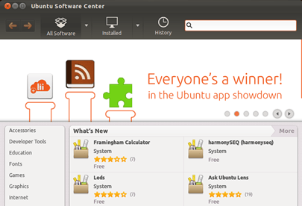

## **Sending E-mails**

For sending mails through terminal you will need to install packages 'mailutils'.

The command syntax is -

***sudo apt-get install***

Once done, you can then use the following syntax for sending an email.

***mail -s 'subject' -c 'cc-address' -b 'bcc-address' 'to-address'***

This will look like:

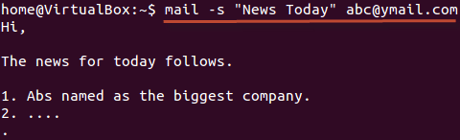

Press Cntrl+D you are finished writing the mail. The mail will be sent to the mentioned address.

### **Summary**

* You can format and print a file directly from the terminal. The formatting you do on the files does not affect the file contents
* In Unix/Linux, software is installed in form of packages. A package contains the program itself. Any dependent component needs to be downloaded separately.
* You can also send e-mails from terminal using the **'mail' command**

|  |  |
| --- | --- |
| **Command** | **Description** |
| pr -x | Divides the file into x columns |
| pr -h | Assigns a header to the file |
| pr -n | Denotes the file with Line Numbers |
| lp -nc  lpr c | Prints "c" copies of the File |
| lp -d lp -P | Specifies name of the printer |
| apt-get | Command used to install and update packages |
| mail -s 'subject' -c 'cc-address' -b 'bcc-address' 'to-address' | Command to send email |
| Mail -s "Subject" to-address < Filename | Command to send email with attachment |